First Mennonite Church • Bluffton, Ohio • Vol. 63, No. 5 • May 2016

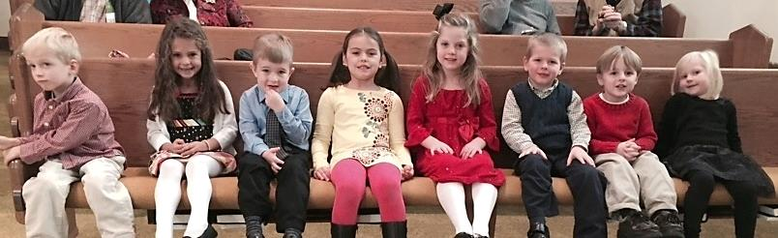

Cherub choir members this year include (from left) Zeke Coffman, Ariana Goings, Kaden Niekamp, Kennedy Longworth, Kari Diller, Ryan Blount, Jorian Mast and Leah Niekamp.

Don’t Be Afraid of Surprises
Rich Bucher
God called me, a farm boy from Allen County, Ohio, to be a pastor. I am the oldest of six children. I am by nature a people-pleaser, meaning I don’t like conflict and I like people to be happy with me. This means that I can be easily satisfied. God has had to work in unusual ways to get my attention. My favorite Bible verses are Isaiah 43:18-19a:
“Forget the former things; do not dwell on the past. See, I am doing a new thing!
Now it springs up; do you not perceive it?”

After graduation from high school, I got a job at the Sylvania television tube factory in Ottawa. I made $58.02 a week and I was happy. But God had other plans for me. In March-April of 1965, I received a lay-off notice. That shook me up. What now? I heard God say, “Now’s the time to do your 1-W service!” (alternative service instead of going in the military.)

I contacted Mennonite Voluntary Service and Mennonite Central Committee. And I said that whichever one responds first is where I’ll go. One day I got a letter from MVS asking me to go to Rosthern, Saskatchewan, Canada, to work with mentally handicapped. The very next day I received a phone call from MCC to go to the Dominican Republic and work with a chicken project. MVS responded first and so I went to Saskatchewan. (By the way, the Dominican Republic had a revolt two months after I entered MVS.)

The years in voluntary service were good ones. I met my wife to be, Carol, and grew up in many ways. I came home and went to Bluffton University (graduated with a social work degree), married Carol, and in 1970 I went to seminary. Going to seminary was not an easy decision. My high school Sunday school teacher and the leader of the youth group kept telling me I needed to go to seminary. I decided that it would look good on my resume and so I said I would go to seminary for a year.

After two months at seminary, I realized that I would stay and graduate and that God had been nudging me through others. One of my years at seminary was spent off campus in London, Ontario in a church setting. It was a practical year of learning. It included clinical pastoral education (two units), preaching, teaching, administration, and counseling.

During April of my senior year at seminary, Carol and I visited some friends at Topeka Mennonite (Indiana), where he was serving as an interim pastor. I made the comment, “I could see myself in a congregation like this.” That word got passed on to the right people and soon the process was started for me becoming their pastor.

The biggest lesson at Topeka Mennonite was learning to say “NO.” Only two letters! I kept doing more and more, going faster and faster, and finally I got depressed. The church gave me a sabbatical of ten weeks. God was working with me, “Are you going to learn to say No?” I did and my life changed. That was hard for me.

God has always used surprises to get my attention. Following ten years at Topeka Mennonite, we accepted a pastorate in Saskatchewan. There were many surprises there. I pastored the church where Elaine Suderman and Tracey Sawatzky grew up. I was their first full-time, paid pastor (1983-1994.)

In 1993, I received a phone call from Mark Weidner, CDC conference pastor, “Rich, how are you doing? Let’s see, you’ve been in Saskatchewan for about ten years. Are you ready for a change?” I responded, “I resigned two days ago.” Mark said, “I’ve got just the place for you. North Danvers Mennonite in Illinois.” (1994-2012) God surprised me again.

In October of 2011, after a routine colonoscopy Carol was diagnosed with stage four cancer in her colon and liver. Surprise! Not all surprises are from God. But we felt God’s presence through it all. I needed to be her husband and not her pastor, so she chose Gloria to be her pastor. I retired the end of February 2012. And on Good Friday, April 6, 2012, Carol died peacefully. Gloria officiated at her funeral.

Surprise, surprise! Gloria and I developed a deeper relationship and we’ve been married three years. The surprises did not end. Since Gloria and I have been married (2013), I have had a liver transplant, recently a knee revision, Gloria has worked as an interim pastor at First Mennonite, and beginning May 2, 2016, Gloria and I will be interim pastors at Salem Mennonite (Elida) for four months.

When will the surprises end? I trust God has many more in store for us. Don’t be afraid of surprises!

Grace-full Way
Wanda Stopher
Following Jesus is a little like riding a motorcycle. Let me explain. When I took the Ohio Motorcycle Training Course, they taught us that wherever your eyes are fixed, there goes your motorcycle and there you go. If you allow it, your eyes will actually guide you smoothly around a curve. On the other hand, if you let your eyes drop, gaze for even a moment at the road beside you, even for a short time, you and your motorcycle will likely end up right there on the road.

When the recalled Vision Task Force and I met together for the first time, March 22, I wondered, “What is the question that matters as we consider the future and possibilities for First Mennonite Church?” It’s another way of asking, “On what will we fix our gaze?” We began our work by getting a sense of where we are now in the life of our community of faith, and where we’ve been recently. Understanding where we’ve been and the current challenges, led us to focus on the future, and what we might need to do to step out into that future.

The guiding question we discovered became, “How shall we steward this experience?” We often think about being stewards of God’s gifts to us, including possessions, abilities, time and even life itself. Yet, we rarely talk about stewarding life’s challenges, journey toward healing, or a difficult life situation. We are only beginning to respond to the question, but one thing seems clear. However we’re called to steward this experience, it will need to be a grace-filled way. It will require of us that we take an honest, unhurried look in the mirror, and that we respond in ways that are gentle and kind to ourselves. It will require a patience to discern together and also an eagerness to respond as soon as the way becomes clear. It will be a grace-filled way, because we will keep our eyes on Jesus as we find our way together.

Vision Task Force Proposal - Summary
(As shared by Pastor Wanda in worship on 04-24-16)
As we are well aware, we as a community of faith are living in a time of uncertainty that has been intensified with Steve’s current hospitalization at Cleveland Clinic, beginning February 2, 2016. There are many unanswered questions and we remain on an uncertain journey together.

At the same time there is excitement about moving ahead. We are learning to know one another as pastor and congregation. I have been tasked with “developing renewed vision for mission.” So while we are aware of the ambiguity that Steve’s health condition brings, we recognize that we are entering a new time in congregational life and that this is a time of readiness to move forward in our life together. Holding all this together, the question that has engaged the imaginations of the Vision Task Force is, “How shall we steward this experience?”

In response, Vision Task Force and I presented a proposal to Council on 04-21-16 that was approved. In brief, the proposal provides direction for the next 12-18 months, beginning June 1,2016. The proposal is twofold. First, is that we move ahead into this new chapter in our lives together by devoting ourselves to a time of discovery and reflection about who we are, to what God is calling us, and how we will invest ourselves to that end. I will lead this process along with an Advisory Group. The process will include many points of entry and congregational participation. Second, is that we will engage a Pastoral Associate for this 12-18 month time period, to support the pastoral needs of First Mennonite Church. Lois Kaufmann, Central District Conference Minister, will facilitate the selection of this Pastoral Associate.

The entire proposal is in church mailboxes and available in the office. It includes many details. Please read it, ask questions, and pray for the church. Please continue to remember and pray for Steve and Janet, for the entire staff, for all those currently filling in to provide temporary coverage, and for the church as a whole, as we discern God’s leading and call into the future.
Thank you!

Update from Steve and Janet Yoder, 4-28-16
We’ve said it many times before, but we’re taking one step at a time on a very uncertain journey. There are highs and lows. This week, Steve returned to ICU in order to treat fluid that has built up around one of his lungs and for testing. This is disappointing, but not at all unexpected. We know that there will be setbacks but we also know that this is part of the care required to move forward. Moving to ICU has actually allowed Steve time to rest and that’s a good thing. We are grateful for the care Steve is receiving and for the love and support of so many family and friends. Right now the best way to support us is through continued prayers. We love to receive mail, electronic and otherwise. On the journey, Steve and Janet

Address for Steve and Janet Yoder: Steve Yoder, J52, c/o Cleveland Clinic, 9500 Euclid Ave., Cleveland, OH 44195.

Happy birthday to:
Robert Ramseyer, 87, May 9
Helen Winkler, 90, May 18
Robert Stratton, 90, May 28

They’re graduating from college!
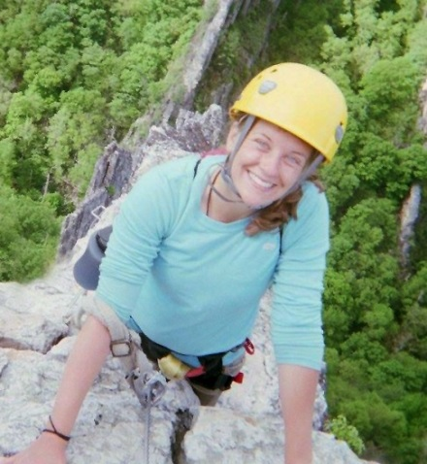
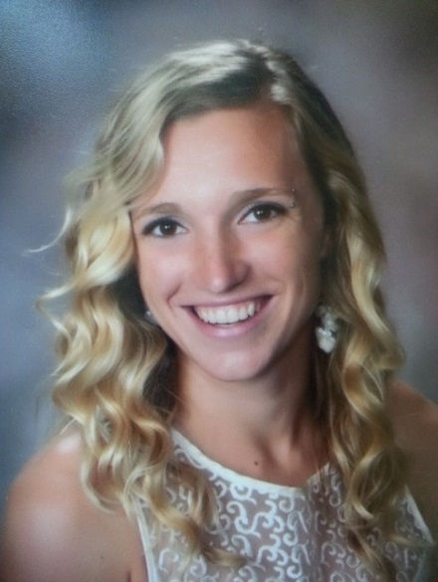
Carissa Luginbill, daughter of Doug and Paula Luginbill. I am graduating from Eastern Mennonite University on May 1, with a bachelor’s in social work with art and psychology minors. This year I have made the dean’s list and am a Cords of Distinction recipient. I'm not 100 percent sure about future plans. However, my two options at this point are volunteering with MVS at the Alamosa, CO placement or working as a program director at a church camp.

Hannah Chappell-Dick, daughter of Wendy and Andy Chappell-Dick, graduates May 1 from Eastern Mennonite University with bachelor’s degree in biology, minors in exercise science and coaching. She was named EMU Athlete of the Year, ODAC Scholar-Athlete of the Year, NCAA D3 All-American (XC & track) and NCAA Academic All-American. She is moving to Atlanta to run for the Atlanta Track Club Elite and will do a year of voluntary service through DOOR/Dwell Ministries in the city.
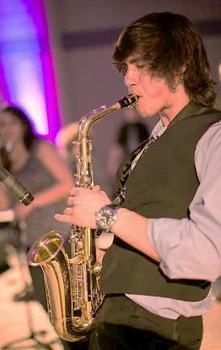
Kallen Terry, daughter of Lucia Unrau and Peter Terry, will graduate May 28 from Hanover College, with a major in history, minor in kinesiology and integrated physiology. She received the Robert E. Bowers History Award. Kallen plans to attend graduate school at University of Northern Illinois, majoring in history, particularly Cambodia and Khmer Rouge.

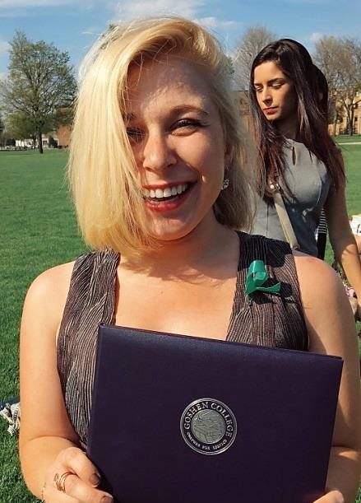
Lucas Harnish graduated April 24 from Goshen College with majors in math and pre-physical therapy. He has been on the dean's list every semester and was a Maple Scholar (3.75 GPA while being on a sports team.) He will be doing one year of voluntary service with Mennonite Voluntary Service in Tucson, AZ, doing house maintenance for low-income families.
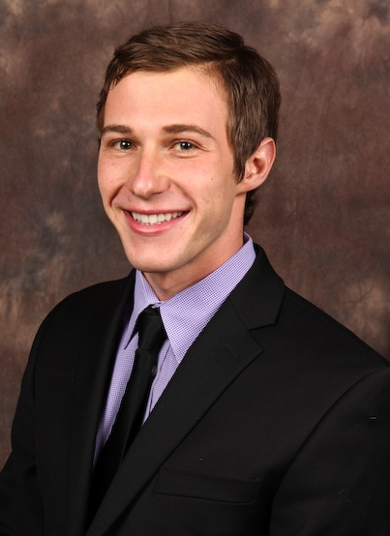
Halle Steingass, daughter of Amy Freeman and Bruce Steingass, graduated cum laude from Goshen College April 24 with a social work major and music minor. After one year of voluntary service with MVS in Seattle, she will attend graduate school.

Logan Steingass, son of Amy Freeman and Bruce Steingass, will graduate May 14 from Miami University with a bachelor of science degree in kinesiology and health. He also graduates from Miami’s honors program and was named to the dean's list. His plans for immediate post-graduation are uncertain, but he does plan to begin applying to physical therapy programs for the 2017 academic year.

Musicians needed for summer worship
Pianists, organists, song leaders, musicians of all ages and types: there are opportunities for offering your musical gifts during the worship services this summer.
Opportunities include:
- Lead the singing for our “opening songs”
- Play piano or organ
- Provide special music during the service, vocally or instrumentally, as a soloist or in an ensemble
Please contact our director of music, Mark Suderman, by phone (419.358.1284) or by email (sudermanme@bluffton.edu.) If you have some specific dates in mind when you could offer your musical gifts, please let Mark know. Thank you!

Mennonite Women meet May 9
Mennonite Women will meet for their May meeting, Monday, May 9, at 7 p.m. in the fellowship hall. Lois Wetherill will present a program titled “Creativity is a Way of Living Life.” Carolyn Rich will lead devotions and Lisa Shelly will provide refreshments. The group will be making decisions on how to spend some of the extra funds, so be prepared to help discern.

Ohio Mennonite Women plan Camp Friedenswald retreat
Ohio women are planning the Sept. 16-18 women's retreat at Camp Friedenswald. The theme is “Gather Around the Table: Nourishing Body and Soul.” Enjoy a weekend of conversations about faith and food inspired by three cookbooks: More with Less, Simply in Season, and Extending the Table. The speakers, Katie Kuntz-Wineland, a seminarian and student minister, and Beth Kuntz-Wineland, a certified plant-based chef, will guide us into reflection about holistic wellness as a spiritual practice. Together, we will ask questions about living simply, embracing the seasons, and practicing hospitality -- how might these commitments shape our relationships with food, God and one another? Come ready to be nourished with good food, rest, and community; leave empowered to nourish yourself and others, create community, and live well. If you would like to participate in planning for the retreat, lead a workshop, help with music, or be involved in some way, contact Lori Nester (NesterL@bluffton.edu or 419-358-9650.) All women are invited to join in this weekend.

SHYF/JHYF
Shannon Thiebeau
Almost unintentionally, the month of April was an opportunity for our youth groups to get acquainted with Bluffton University. Although many of our youth have parents who are affiliated with the university in some way or another, they were able to have some different experiences than what they might be used to.

On April 10, we attended the Sunday night worship and a concert by Adam Cappa, a contemporary Christian artist. This event was the kick-off to the university’s Spiritual Life Week, which is hosted by campus ministries to engage students in conversations about their faith. The guest speaker for the week was Cyneatha Millsaps, who is the pastor of Community Mennonite Church in Markham, Il. Many of our youth heard her speak at the Kansas City convention this past summer and were eager to listen to her again.

For College Relations Sunday, we hosted Bluffton students Alyssa Kauffman and Blake Hershberger for a Q&A session with the junior high and senior high Sunday school classes to talk about the Mennonite universities and discerning what to do after high school graduation. A huge thank you to Louise Matthews for facilitating this discussion!
We are excited for May to arrive…the end of school, graduation for our high school seniors, and Youth Sunday on May 15!

JHYF scavenger hunt
JHYF had a scavenger hunt April 24 at the Bluffton University nature preserve. As part of the activity, each team was required to take a photo that represented how they found God in each other. These are some of the results of the photo sessions.

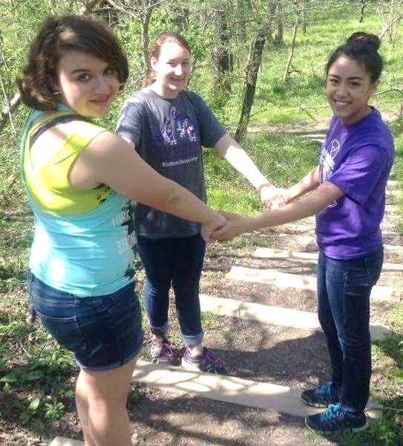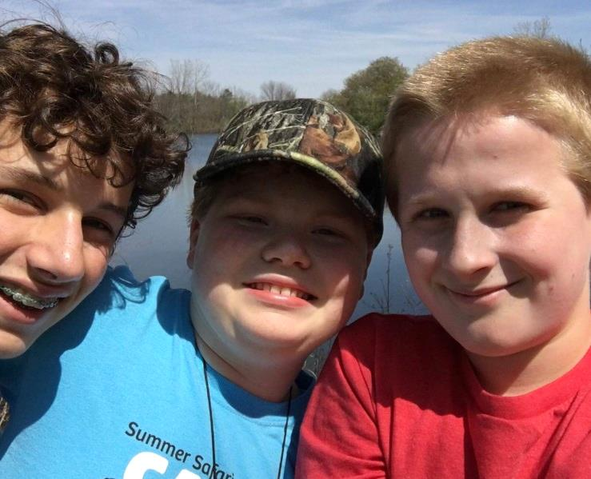
At left from left, Sophia Gott, Grace Paquin and Anneliese Nisly. Below from left, Jacob Biesecker-Mast, Patrick Estell and Jacob Suter.

Camp Friedenswald – Summer camps and camperships
Get ready for summer at Camp Friedenswald! This year’s theme for the summer is “Who is Wise?” which will focus on 1 Corinthians 1:18-31. Listed below is the camp schedule for the summer:
High School (Grade 9-12): June 13-18
Jr. High Camp (Grade 7-8): June 20-25
Primary Camp (Grade 1-2): June 20-22
Pre-Junior Camp (Grade 3-4): June 27-July 2
Junior Camp (Grade 5-6): July 4-9
Family Camp 1: July 11-15
Family Camp 2: July 18-22
Camperships are available from FMC to offset the cost of camp fees for children and youth. Please contact Mary Ina Hooley (hooleymi@bluffton.edu) with any questions. Please consider the grade completed in 2016 in registering your child or youth. For more information and to register, visit https://friedenswald.org/summer-camps/ or call 269-476-9744.

