First Mennonite Church • Bluffton, Ohio • Vol. 63, No. 4 • April 2016

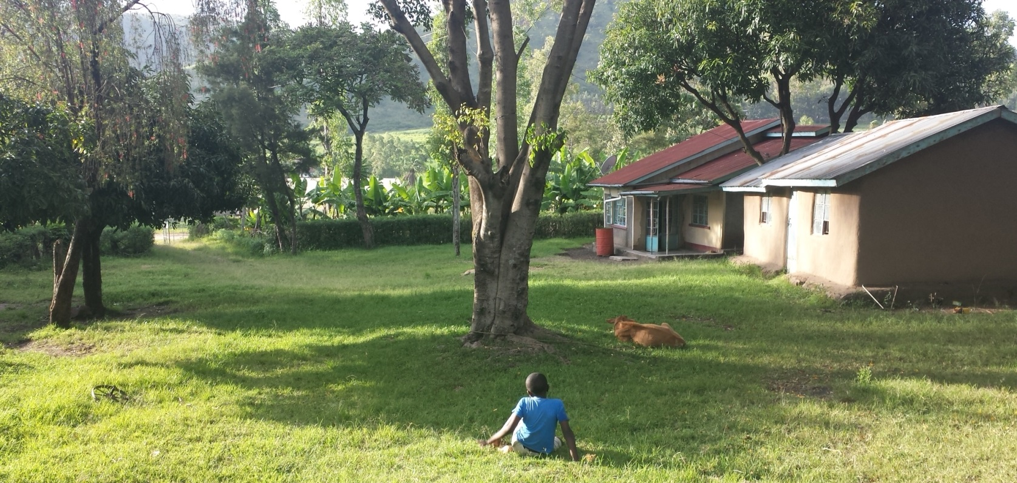

Eastertide
Wanda Stopher

Though we often think of Easter as a day of celebration, in the Christian liturgical calendar, Eastertide is a whole season of celebration that culminates with the celebration of Pentecost. Each Sunday in this fifty day period is another Easter. Actually, every Sunday in the church year is a celebration of resurrection, but in Eastertide, the gospel stories recount the appearances of Jesus after his resurrection and in the lectionary, the prophetic texts are replaced with accounts of the early church in Acts, enlivened by the Spirit in a repeat incarnation of God in the newly formed body of Christ!

How will we celebrate Eastertide this year at First Mennonite Church? How will we practice resurrection? How will we position ourselves to witness it in our midst and to recognize it when it happens? How will we name the resurrections we experience, great and small?

Will we? How will we? In the words of the old television show, Mission Impossible, “Your mission, should you choose to accept it…”is to practice resurrection this Eastertide. How you celebrate or practice will be as different and unique as one person is from another. As for me, I’ve decided I’ll write. I’ll pay attention to resurrections great and small in and around me. And I’ll write a fifty word reflection each day for these fifty days of Eastertide. However you celebrate, I welcome your presence with me on this journey. I welcome conversations about how you will choose to celebrate, and later about what you’re discovering along the way. Share with me! I’ll share my own reflections on the church website. May God’s own Spirit enliven our celebrations!
Update from Steve and Janet Yoder, 3/23/16
Steve has been moved to an area where he will start cardiac rehab with his total artificial heart. He tires very easily and needs to regain strength for the continued journey ahead. We are thankful…Janet Yoder

Address for Steve and Janet Yoder: Steve Yoder, J52, c/o Cleveland Clinic, 9500 Euclid Ave., Cleveland, OH 44195.

The words below are from a card from Janet and Steve, which is now posted on the Congregational Life pillar in the fellowship hall:

Dear Friends at FMC: Faith is taking the first step even when you don’t see the whole staircase. (Martin Luther King, Jr.) I wish I could say we are at the top of the staircase…looking down and saying we are here – not so…slow climb. Thanks for your continued gift of money through the Benevolent fund…May the grace and peace of Christ be with you all. Blessings, Janet for Steve

Happy birthday to:

Lawrence Templin, 94, April 4
LaVonne Klassen, 93, April 14
Helen Brooks, 87, April 18
Anna Ruth Balmer, 93, April 30

Happy anniversary to:
Lynn and Linda Miller, 51, April 2
Eileen and Neil Kehler, 60, April 7

In our prayers…
Bob Ramseyer continues in care at Mennonite Memorial Home. He and Alice Ruth appreciate your prayers and support.

Gratitude…
Thanks so much for your many expressions of caring support and prayers during my recent surgery. I feel truly blessed to be part of this loving church family. -- Anne Buller

Thank you all for the many expressions of caring and support following the death of our mother, Wanda Pannabecker. She loved her church family and so appreciated your cards, visits and prayers, especially when she was no longer able to be here.
-- Mary Pannabecker Steiner, Phil, John, James and Tom Pannabecker and families

Dick and I want to thank you for your prayers, support, & encouragement during this extremely difficult time in our lives. We thank you for the many ways you “walked” with us on our health journey and are continuing to do so. You showed us the outpouring of your love through your sharing of food, cards, notes, calls. Blessings for each of you as you continue your own daily journey. -- Dick and Elfrieda Ramseyer

Hooleys travel to Kenya to visit their son, David
Don and Mary Ina Hooley traveled to Kenya March 3-12 to visit their son, David, a 2015 Goshen College graduate. Mary Ina provided the Menno-Life with this report on their trip.

David is volunteering with MCC SALT for one year in Songhor, a village in rural western Kenya. He lives with an extended host family of 12 persons including a grandmother, two of her sons, a daughter and their families.
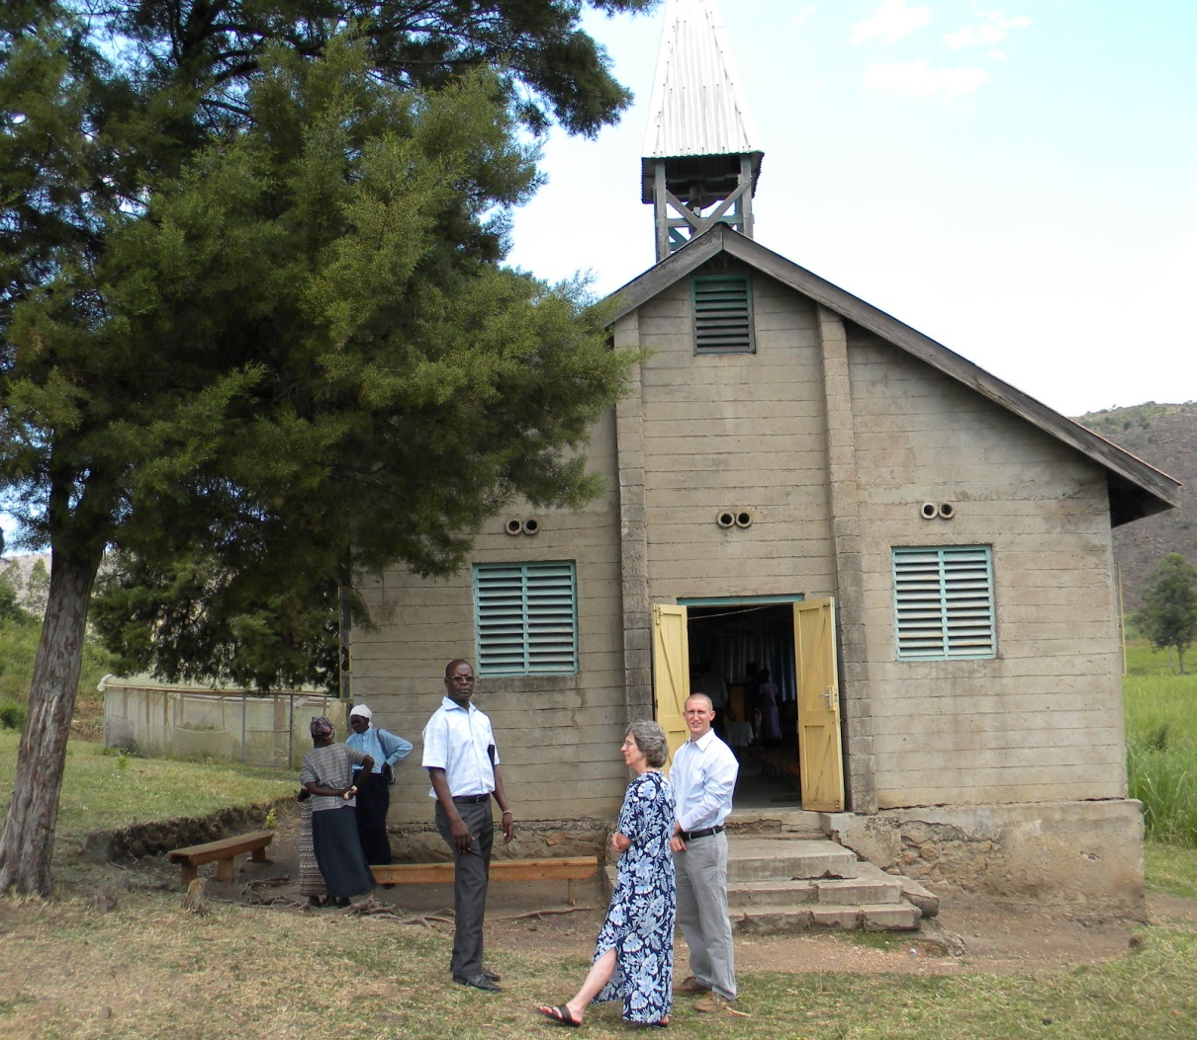
He assists with math and physics classes in the local public high school. David also teaches computer classes and does some web support at a Resource Center, a development outreach of the local Mennonite church. Resource Center personnel direct educational, aid and agricultural projects such as feminine hygiene classes, life clubs, vegetable and milk goat farming and support a young adult Peace Ambassadors program with a neighboring tribe.

Above, Mary Ina (center) and David Hooley and church members gather outside Songhor Mennonite Church

David met us in Nairobi, the capital city. After a night in a very comfortable guesthouse, we rode in a bus and then, private car, a total of nine hours to reach Songhor. We spent parts of five days in Songhor going to David’s places of work and meeting the staff at each location. We also enjoyed a worship service at the Songhor Mennonite Church, hiked a small hill with some of David’s friends, and enjoyed much good food (mandazi – a deep fried sweet bread is a favorite) and conversation with his host family. Everyone was very welcoming.

One day we drove to Kisumu, a town an hour’s drive away on the shores of Lake Victoria. There we enjoyed a fresh fish meal and a boat ride to view a pod of hippos.

We ended our trip with two days back in Nairobi. The highlight there was a drive through the Nairobi Game Park where we saw zebra, giraffe, water buck, crocodile, large and small deer, ostrich and rhino. We also spent time with the MCC country rep, Selena Carpenter, who took us to Rosslyn Academy where her children attend.

We are so thankful for the wonderful trip experience—safe traveling, good health, warm hospitality, beautiful scenery, new relationships and many good conversations. Thank you to all who signed the posters for Songhor Mennonite Church and David. They were greatly enjoyed and appreciated.
-- Mary Ina and Don Hooley

At left, David Hooley and some of his co-workers at Songhor Resource Center.
Below, zebras seen during a drive through Nairobi Game Park.

*Note: The following two paragraphs are from David Hooley’s blog. If you’d like to read more about his year in Kenya, see his blog at: https://davidhooleykenya.wordpress.com

Blog post, Nov. 24, 2015: To give you all an idea of a ‘normal’ day in Songhor, I will describe what an evening usually consists of. After returning from school or the Resource Center, I often have a cup of tea and catch up with some family members on how their day went. Then, if it is not raining (it is currently the rainy season, so it rains almost every day at some point), I like to go for a run. My runs usually include plenty of children shouting “Mzungu, how are you??” (mzungu essentially means ‘white person’ and ‘how are you’ is about all the english a small child knows) and also some pretty spectacular views of the beautiful valley and mountains surrounding me. After bathing, I have some alone time or interact with some of my family members until supper. Meal time is always an event with the the three boys I eat with (ages approximately 11, 13, and 15). We have also been watching La Gata, a mexican drama on TV that airs 6 nights a week. It is surprisingly entertaining and has became a family tradition! By about 9:15 I return to the house where I sleep, but before bed, 5 family members and I have a time of singing and prayer. I have really appreciated this tradition of singing in Swahili and group prayer to end a busy day.

Blog post, March 2, 2016: As Christmas approached, not much changed in the village. Community members carried on with their lives as normal, but the evening of the 24th was a different story. I had heard about this ‘all-night’ Christmas service, but I really didn’t know what to expect. At about 9pm on Christmas Eve I went with my family members and we all gathered at the local Mennonite church for a service. We started with song, prayer, scripture, and a sermon or three that ushered in Christmas Day and ended around 1am. Then we began a time of special music presentations where about any combination of people you can think of presented some sort of music! I thoroughly enjoyed the variety of presentations and sang a couple songs with some family members. Then, from about 3am to 7am we sang, listened to a speaker, or prayed until the sun came up (a lot of people slept too!). Most people then went back home to finally sleep! It was such a different experience for me, but so amazing to spend Christmas morning singing and celebrating the birth of Christ and not worrying about what gifts we were going to give or receive.

Mennonite Women project month: Comforter knotting April 11-12
April is project month for Mennonite Women. On Monday, April 11, at 7 p.m., comforters will be set up in the fellowship hall for knotting. Mary Amstutz’s devotional will focus on the theme, “For Creative Success, the Most Important Audience is the Audience of One.” Refreshments that evening will be prepared by Louise Matthews and Julie Mackey. Comforter knotting will continue on Tuesday, April 12, from 8 a.m.-noon, followed by lunch together at noon. Women, please bring a salad or dessert. Sandwiches and beverages will be provided.

Lynn Miller to supervise construction of MMN project
Mennonite Mission Network’s SOOP program has asked Lynn Miller to be the construction supervisor for the a new thrift store building on the Cheyenne Indian reservation in Lame Deer, MT, this spring. Lynn will leave for Montana on April 4 (and can take one person with him) to begin the construction of the first floor of the 9,000 square foot building. SOOP is recruiting volunteers to work as framing carpenters, laborers, cooks, and drivers (the nearest lumberyard is 104 miles away). If you might be interested in working with Lynn on this project, either speak to him or contact Arloa Bontrager at SOOP (ArloaB@MennoniteMission.net For more information about the thrift store go to www.EverythingBeautifulThriftStore.org or see their Facebook page using the same name.

SHYF/JHYF updates
From Shannon Thiebeau, FMC youth ministry coordinator

In March, the JHYF tackled questions about the importance of taking care of the environment and the biblical reasons for taking care of creation. In April, we look forward to discussing diversity and exploring the Bluffton University Nature Preserve for an Earth Day Bible study. In addition, Louise Matthews, Phil Birkey, and several Bluffton University students will be speaking to the Jr. and Sr. High Sunday school classes about why they chose a Mennonite college.

The SHYF has been working on a CDC video contest that showcases the way our congregation expresses the CDC’s theme of “Abounding in love, abiding in grace.” We’d like to give a shout out to Ray Raeburn for helping us by compiling pictures for our video. The high school group, along with Lynn and Linda Miller, also had the opportunity to help John Murray move into his new apartment. We had fun coming up with creative ways to move large pieces of furniture and securing them on the trailer!

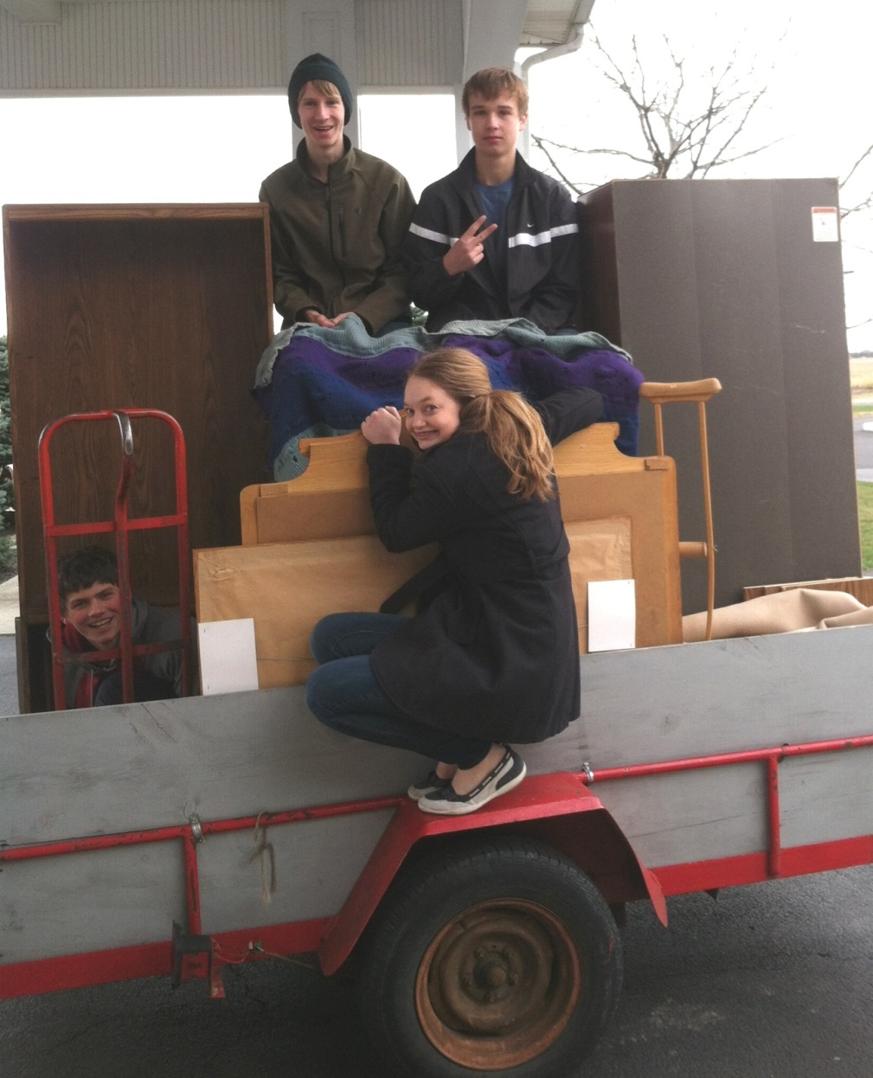

Moving day!
With the help of Lynn and Linda Miller and their truck and trailer, the SHYF helped John Murray move into his new apartment at the Mennonite Memorial Home.
According to Shannon Thiebeau, youth ministry coordinator, the youth had fun coming up with creative ways to move large pieces of furniture and securing them onto the trailer!
At left are Christopher Harnish (far left, crouching behind the red two-wheeled hand truck), Isaac Andreas, Douglas Nester and Cassidy Bush. (Hidden from the camera in a cupboard is Seth Andreas.)

