First Mennonite Church • Bluffton, Ohio • Vol. 67, No. 2 • April 2020
Connecting as a community, far and wide
In this time of social distancing and anxiety and threat, I’ve been thinking a lot about connection -- about us as a community, as God’s kin-dom people.
Father Richard Rohr wrote in his daily devotion on Sunday, 03-22-20, “When we carry our own suffering in solidarity with humanity’s one universal longing for deep union, it helps keep us from self-pity or self-preoccupation. We know that we are all in this together. It is just as hard for everybody else, and our healing is bound up in each other’s. Almost all people are carrying a great and secret hurt, even when they don’t know it. This realization softens the space around our overly-defended hearts. It makes it hard to be cruel to anyone. It somehow makes us one—in a way that easy comfort and entertainment never can.”
On All Saints Day we are reminded that the community of saints is connected, even across the great divide of death. I recently viewed again, a sermon that Pastor Steve Yoder offered on December 20, 2015…what turned out to be one of his last sermons among us. It was titled They Shall Live Secure, and it was about the difference between safety and security. He might preach the same sermon today, with a few additional examples. That’s a sign of a great sermon. I commend it to you. You can find it on the FMC website!
We are connected across the great divide of death. We are also learning daily that we are deeply connected across the space between us, even when that space is far and wide. I recently received a prayer from another pastor who served at FMC and whose love for us continues across space. Dorothy Nickel Friesen wrote this prayer, and gave permission for me to share it with you.
Prayer for Spring 2020
Part I:
God bless the empty pews, chairs, and nurseries.
We bless the memory of those who imagined a church building,
Who drew it, framed it, hammered and painted it;
Who bowed in dedication of this sacred space.
We pray with thanksgiving for the baptisms, marriage covenants,
Ordinations, and funerals
When rituals guided our souls
And this space held our holy bodies.
We remember the music, choir anthems,
Children’s high voices, piano, organ,
Violin and instruments of all sizes, shapes and orchestral genius
That filled every square inch from floor to ceiling
With wordless praise, lament, and benediction.
God bless the empty pews where prayers ascended,
Thoughts swirled with provocative preaching,
Eyes dimmed with tears of joy and tears of sadness in powerful prayer.
God bless our empty chairs which were re-arranged
From worship, to potluck, to support circles;
Stacked and shoved to closets, storage,
Then moved again to hold little ones and senior saints—
And all ages in between.
God bless our empty nurseries, classrooms, and janitors’ closets;
Bless the hidden spaces where curriculum is stacked,
Bless the rocking chairs, cribs and playthings now
Sidelined, quiet, and waiting wiggly hands and squealing yelps.
God bless empty spaces awaiting a community who unites in hope.

Part II
God bless our hearts as we open them to new experiences in this season of required separation.
God bless this springtime of opening buds, greener grass, and leafy trees.
God bless our minds as we renew our faith with biblical texts.
God bless our souls as we pray for insight, hope, and strength.
God bless caregivers and all those who need care.
God bless the pews, chairs, and nurseries as they await re-filling.
Amen.
~ Dorothy Nickel Friesen
So in the words of the title of a book of blessings by John O’Donohue,
May God “Bless the Space Between Us”
May God bless the space and time we share, and even the space and time that seeks to divide. May God’s abundant life break forth in and around and among us destroying the power of death and destruction! Amen.
~ Wanda Stopher
Summer Music
Assuming we are back to a more normal schedule…
Pianists, organists, song leaders, musicians of all ages and types: there are again opportunities for offering your musical gifts during the worship services this summer (June-August).
Opportunities include:
- Lead the singing for opening songs
- Play piano or organ for the service
- Provide special music during the service, vocally or instrumentally, as a soloist or in an ensemble
Please contact our Director of Music, Mark Suderman by phone (419.230.5368) or by email (sudermanme@bluffton.edu). If you have some specific dates in mind when you could offer your musical gifts, please let Mark know. Thank you!

They’re graduating!
Touching base with FMC’s high school seniors
Do you know all of the high school seniors at First Mennonite? In case you’ve lost track, we have six seniors this year, including Ana Neufeld Weaver, Grace Paquin, Sophia Gott, Danielle Novak, Jacob Biesecker-Mast, and Patrick Estell. This month, we profile Patrick Estell and Jacob Biesecker-Mast.
Senior: Patrick Estell
Family: Parents, Melinda and John Estell; sister, Rebecca Estell
Plans after graduation: Study biology at the College of Wooster.
1. Describe yourself in 5 words or less.
A musical science guy.
2. What are 3 things are you grateful for in your life and why?
My parents, for shaping me into the man I am today; the Bluffton Nature Preserve, it allowed me to keep a love of nature throughout my childhood; my Uncle Scott, for encouraging me to follow my passions of biology, and for teaching me how to hunt.
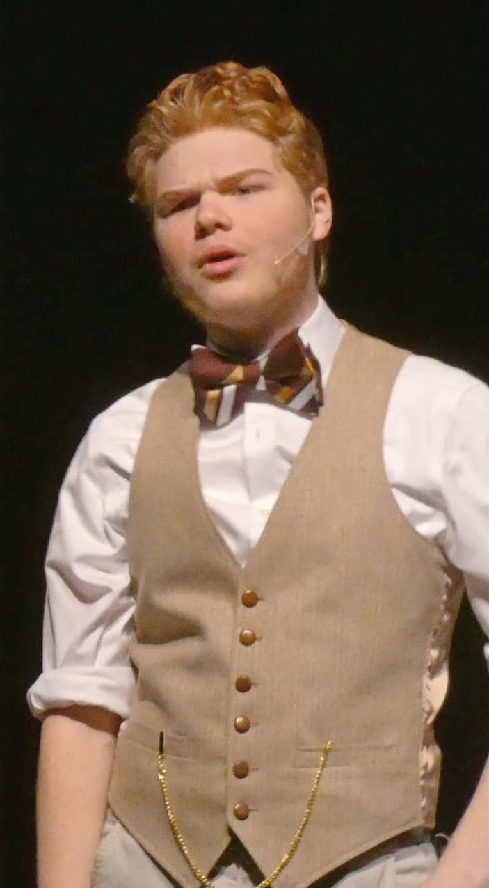
3. What have you learned in life that you feel will be the most useful?
Learning how to do dramatic acting.
4. What’s a hobby that you don’t currently do that you’d love to learn? What’s holding you back from starting?
Learn to play the bagpipes, the thing holding me back is I am busy with a lot of other activities in my life.
5. Imagine you’re the teacher tomorrow at school. What are 3 things you’d teach that you think would help make school more useful for one’s future?
Always stay away from drama, if you want to pursue an interest pursue it, and you can always turn your life around with hard work.
6. If you could travel back in time 3 years, what advice would you give yourself?
Do show choir, do regular choir, and do drama club.
7. What is the achievement you’re most proud of and why?
Getting the role of the Scarecrow in the Wizard of Oz last year, it was one of the most tiring and rewarding roles I’ve gotten in the drama club. I had to really push myself to be present in each moment.
8. If you had no physical, financial or other obstacles, what skill would
you like to have?
How to do prop and scene building for theatrical productions.
9. What (or who) has had the greatest impact on your life and why?
The high school band has had a mixed impact on my life, but probably the greatest. I have made many friends through the band, but also some enemies. The band allowed me to feel more comfortable auditioning for the show choir and drama club.

10. If you could eat dinner with 3 people you don’t know, who would it be and where would you go?
I would eat dinner with Gordon Ramsay, Adam Savage, and Steve Irwin, and we would go to Japan West to eat.
11. Where in the world would you most like to live? Why?
The Pacific Northwest, because there are miles upon miles of forest and vegetation for me to explore, hunt, and fish in.
Senior: Jacob Biesecker-Mast
Family: Parents, Carrie and Gerald Mast; Sue and Bill Trollinger; sister, Anna Biesecker-Mast; brother, Jorian Mast
Plans after graduation: Attend University of Dayton.
1. Describe yourself in 5 words or less.
I like to think.
2. What are 3 things are you grateful for in your life and why?
My parents, they shaped me to be who I am proud to be today; My church family, they have taught me a lot about how to be in the world; My teachers at school, they have taught me most of the stuff that I will need in the future.
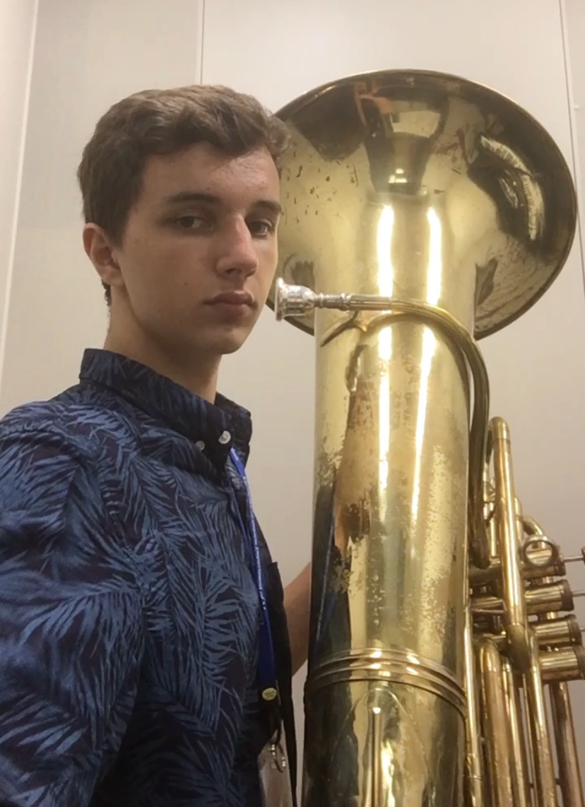
3. What have you learned in life that you feel will be the most useful?
There are almost no exceptions.
4. What’s a hobby that you don’t currently do that you’d love to learn? What’s holding you back from starting?
Rock climbing, too dangerous and there is no easy access to rock faces near where I live.
5. Imagine you’re the teacher tomorrow at school. What are 3 things you’d teach that you think would help make school more useful for one’s future?
It’s okay to take risks, but don’t be reckless. There is never a downside to being well rounded. Time is limited, be thoughtful about what you choose to spend it on.
6. If you could travel back in time 3 years, what advice would you give yourself?
Learn as much as you can from every mistake.
7. What is the achievement you’re most proud of and why?
I am very proud of who I am right now, but I can’t take full credit for that.
8. If you had no physical, financial or other obstacles, what skill would you like to have?
I would like to learn how to think better.
9. What (or who) has had the greatest impact on your life, good or bad, and why?
It’s hard to say who has impacted me the most but my parents have definitely had a huge effect on who I am today because they are incredible people who I look up to and respect sincerely.

10. If you could eat dinner with 3 people you don’t know, who would it be and where would you go?
Anyone who is really passionate about what they do. Probably at this really nice restaurant in Cincinnati called Orchids.
11. Where in the world would you most like to live? Why?
New York City or Chicago. I like big cities.
Getting to know…Carlin Carpenter
By Joanne Niswander
If you have lived around Bluffton for any length of time, you know the name Carlin Carpenter. Coach of the Bluffton Beavers football team for 25 years, Carlin has earned his mark at the college as well as the community.
But let's begin at the beginning -- 1938 -- the year Carlin was born. The Carpenters lived in Nelsonville, Ohio. Carlin's father worked for Standard Oil and his mother was a school teacher. Carlin attended both elementary and high school there.
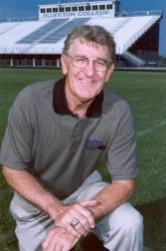
After graduation, Carlin spent four years in the armed services. Then, in 1961, he married Sharon, another Nelsonville native. They began their married life as freshman students at Defiance College.
After Carlin received his degree in psychology and biology from Defiance, he and Sharon began 10-plus years of moving from place to place as job opportunities arose. From Defiance, they moved back to Nelsonville where Carlin worked for the Ohio State Employment Service for a year. Their first daughter, Kelly, was born in Nelsonville.
Then Carlin received a scholarship to enter a doctoral program in microbiology at the University of Massachusetts. This was a huge move for the family, both physically and psychologically, and Carlin soon discovered that living on the east coast was not for him. So the Carpenters moved back to Ohio.
Carlin began then what turned out to be his long teaching/coaching career in Amanda, a small town southeast of Columbus. In addition to teaching chemistry and biology, he was asked to be assistant football coach. After two years at Amanda, Carlin returned to Ohio University to work on a graduate degree.
In 1970, he returned to Defiance College -- this time as a professor and assistant coach. After a year at Defiance, he joined the coaching staff at Ohio University for four years. During those years, the Carpenter's second daughter, Jill, was born.
The next four years were devoted to teaching and coaching at Marshall University in Huntington, WV, before moving to Bluffton in 1979 to coach and teach at Bluffton.
At the time Carlin took over at Bluffton, the football program was small and struggling. Carlin brought with him enrollment skills that soon helped bring new life to the athletics department. But recruiting was hard work. He and Sharon traveled extensively to meet new recruits and their parents. "We worked our tails off."
Their work paid off in bigger and better teams, with some invigorating championship years. "Sharon was an excellent recruiter," Carlin says. Although Sharon held a full-time job in the college's main office, she juggled her time so that she could travel with him and help win over the mothers of his recruits.
There was family at home to support as well, as Carlin and Sharon's two daughters were involved in many Bluffton school activities. Today the girls and their families live close by, with one in Bluffton, the other in Bowling Green, and now the Carpenters cheer on their four grandchildren.
Since retiring in 2003, Carlin has kept busy as a public speaker and writing a book about his coaching experiences. Carlin also has time to play golf, fish, and attend sports events.
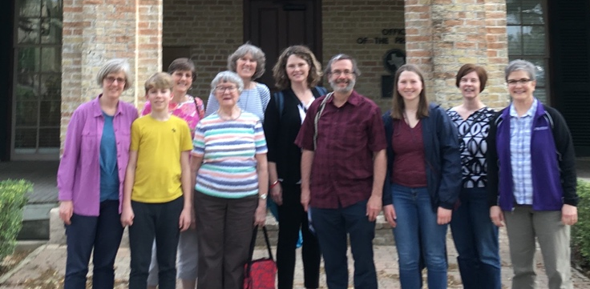
FMC group travels to Rio Grande Valley to learn how to help;
observes significance of migration in border communities
By Jan Wiebe
As our country builds a wall and passes stricter immigration policies, First Mennonite church members have been talking about what Christians can do to help the immigrant, as Jesus calls us to do. On March 3, ten individuals from FMC traveled to the Rio Grande Valley, TX, to learn more of the social, economic, and political significance of migration in border communities. We felt fortunate to have this experience just before COVID-19 made travel risky. The group included Fran Core, Melissa Friesen, Theda Good, Monica Harnish, Lynda Nyce, Jan Wiebe, Theo Andreas, and Paul, Laurel, and Ana Neufeld Weaver. Lynda has led many trips to this region and we benefited from her knowledge and many connections.
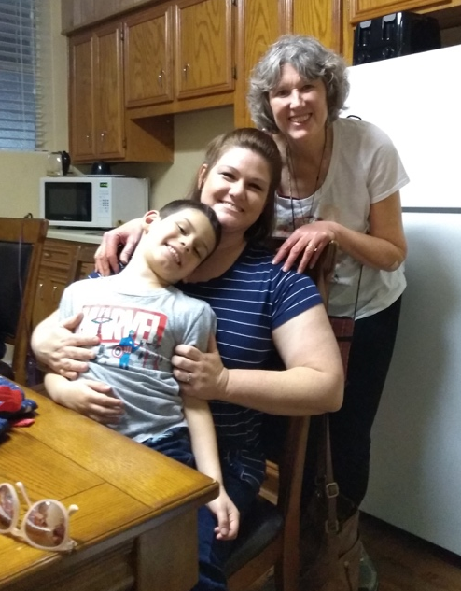
We heard about life in the border communities from service providers, businesspeople, churches, community organizers, and legal representatives. We learned that the Metropolitan Statistical Area is the poorest in all of the United States. We learned, or tried to learn, the complex immigration pathways and the many dead ends that most people encounter. We tried to understand why the number of deaths of those crossing the border has doubled since 1995. We saw the border wall in its various forms and saw where it was splitting nature preserves and individual’s land in two. We heard stories from friends now living in the region, including Tami Cupples Hernandez and her son, Archer. Tami grew up in Bluffton, attended FMC and moved to the Valley in 2000, and is an editor at The Monitor in McAllen, TX. We hung our feet in the Rio Grande River and prayed as we remembered those who have lost their lives in this river, and those who gained access to a life we take for granted. Each day we had devotions together and reflected on what we were experiencing.
We spent one morning listening to asylum hearings at the Immigration Court in Harlingen. In one courtroom, we heard a 23-year old man explain why, after death threats, extortion and poverty, he had left El Salvador with his wife to try to come to the US. He explained his case via a videoscreen in the detention center. In another room, a woman with a baby on her lap shared her case for asylum. That evening, we were warmly received by the New Dawn Mennonite Church, which meets in the house of the pastor Nena Bennett. For two hours, we worshipped together in song and sharing.
Archer and Tami Hernandez and Laurel Neufeld Weaver
“The most memorable thing from the trip was making and serving food for people in the tent camps,” said Theo. On Friday, we volunteered with World Central Kitchen, which provides meals in the aftermath of natural disasters and other crises. We prepared paella for 1,200 asylum-seekers who were camped out in tents in Matamoros, Mexico, while waiting for their hearings. We walked across the border with dozens of wagons, pulling the hot meals, as well as sandwiches for the next day’s breakfast. We served food for two hours, trying to look in the eyes of and smiling at every person. We also volunteered at a respite center that usually houses and feeds hundreds of people daily. Due to the “Remain in Mexico” policy passed in January 2019, the center is unable to serve many people in their facility, so they have shifted their work to taking staples across the border to the people in the tent camps – beans, rice, cook stoves, soap, and diapers.
We learned that there are not simple solutions, but there are certainly things that could be done to treat immigrants more humanely, keep families together, work toward more justice in the world, and recognize how we benefit from having immigrants among us. It was not hard to see God’s Spirit in the refugee, the migrant, the unaccompanied minor, and the many people dedicating their lives to serving our neighbors.
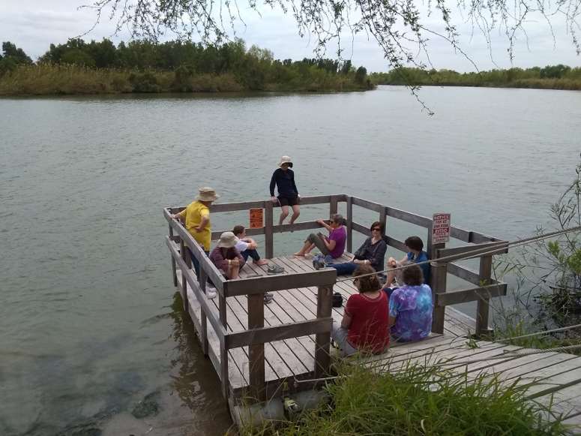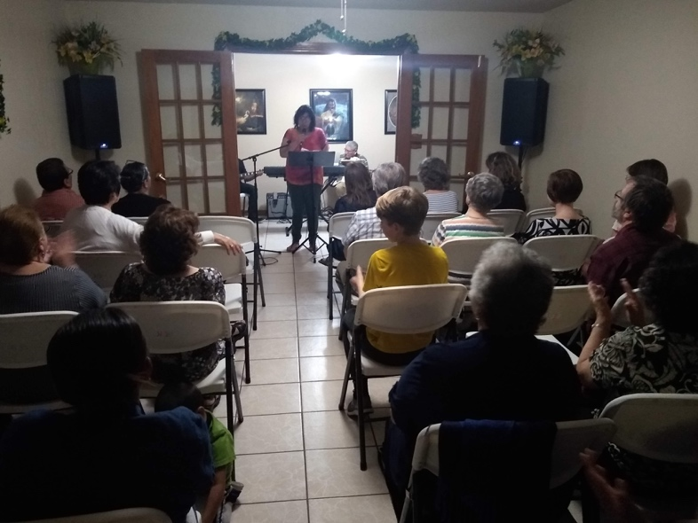
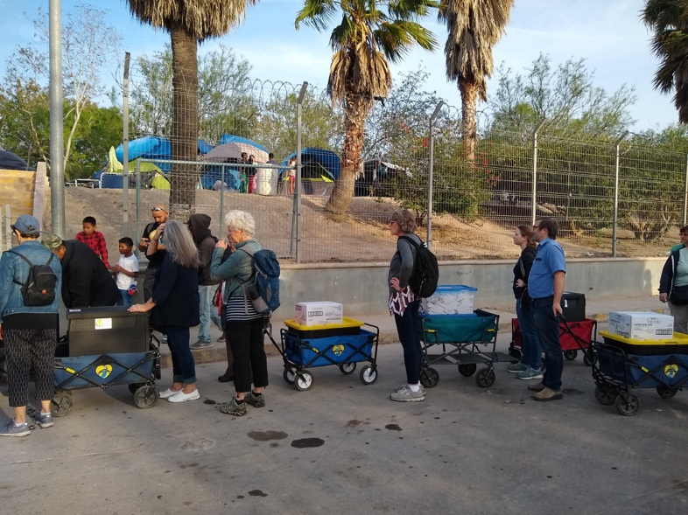
Top left: Sharing devotions on the Rio Grande. Top right: Worshipping at New Dawn Mennonite Church. Bottom left: Delivering hot meals across the border to a camp housing asylum seekers.

Rohr, Fr Richard. https://mail.google.com/mail/u/1/#inbox/FMfcgxwHMPpnbkfVfVjXpxdmtHvZGGSD

